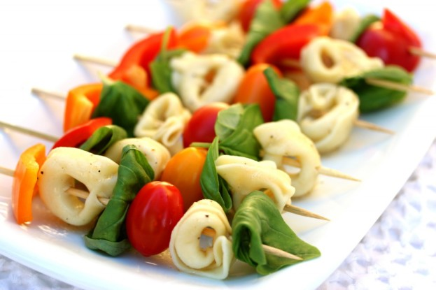
Ingredients
- 1 package cheese tortellini
- 1 red bell pepper
- 1 orange bell pepper
- 1 pint of grape tomatoes
- fresh basil leaves
- Bamboo skewers

Instructions

Cook the tortellini according to the package (use a big pot to cook the pasta in with a lot of water and always salt your water, it should taste like the ocean). Cut the peppers into 1 inch pieces and wash the basil and tomatoes. Assembly the skewers. Place finished skewers on a serving plate and drizzle with dressing.

