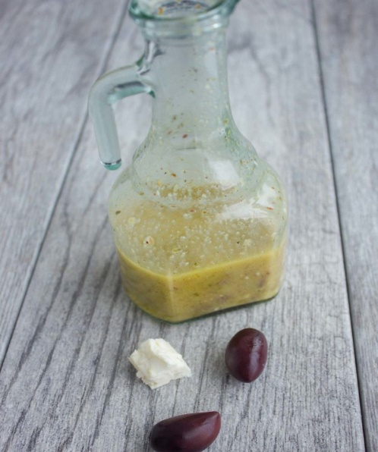

Ingredients

- 1 ½ qts. olive oil
- 1/3 cup garlic minced
- 1/3 cup dried oregano
- 1/3 cup fresh basil
- ¼ cup pepper
- ¼ cup salt
- ¼ cup Dijon mustard
- Juice of ½ a lemon
- 2 qts. red wine vinegar

Instructions

In a very large container, mix together the olive oil, garlic, oregano, basil, pepper, salt, and Dijon mustard. Slowly pour in the vinegar, and mix vigorously until well blended.

