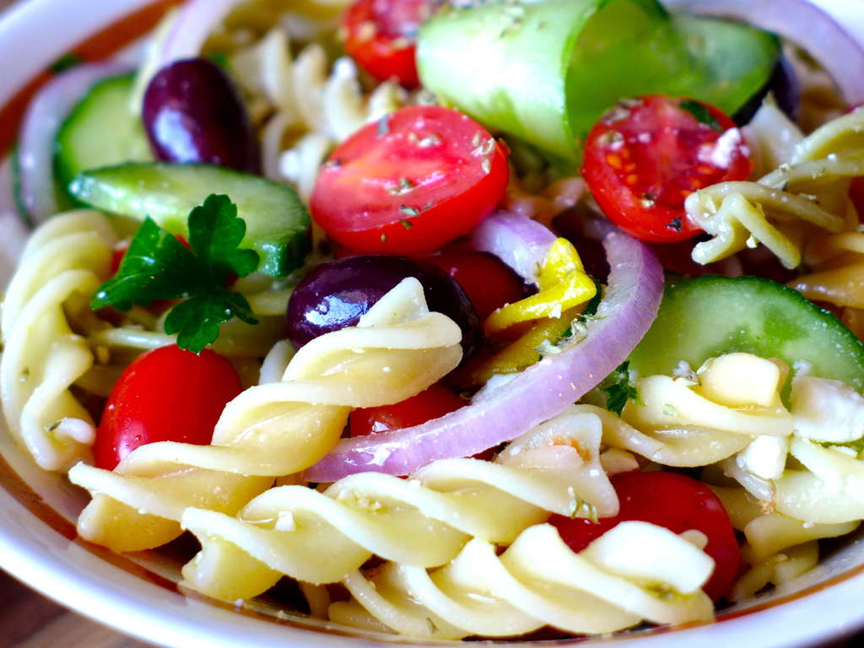
Ingredients
- 16 oz. Fusilli pasta
- 1 pt. Cherry tomatoes, cut in half
- 1 Red onion, sliced
- 1 Red bell pepper, sliced
- 1 English cucumber, sliced into half moons
- 1 pt. Kalamata olives
- 8 to 10 oz. Feta cheese, crumbled
- 2 TBS. Chopped parsley
Instructions
- To prepare this Greek pasta salad recipe, start by cooking the pasta. Boil the pasta according to package instructions and drain. (use a big pot to cook the pasta in with a lot of water and always salt your water, it should taste like the ocean) Set aside to cool down for a while.
- In the meantime, prepare your vegetables for the Greek pasta salad. Wash thoroughly and strain the vegetables. Cut the tomatoes in half, the cucumber into half-moons, slice the pepper and the red onion. Place all the vegetables in a large salad bowl and add the pasta, the olives and feta cheese.
- To prepare the dressing for the Greek pasta salad add all the ingredients in a bowl and whisk to combine.
- Pour the dressing over the Greek pasta salad and toss to coat. Taste and adjust the seasoning according to preference.
- Prepare this Greek pasta salad recipe a few hours before serving to allow the flavors to develop.
- Divide the Greek pasta salad among individual serving plates. Garnish with chopped parsley and serve cold. Enjoy!

